Testing

|  |  |  |  |
| --- | --- | --- | --- |
| Test description | Input | Expected out | Actual out |
| Logging in with correct details | Username: test  Password: test | Successful login |  |
| Logging in with incorrect details | Username: ASASD  Password: ASASD | Unsuccessful login message |  |
| Pressing logout button | Press logout button | Logs out successfully |  |
| Add a pizza | Add small original | Successfully adds |  |
| Adding a create your own pizza | Add create your own with jalapeno and pepperoni | Successfully adds with correct toppings |  |
| Trying to submit without being logged in | Pressing submit button | Error message will display |  |
| Trying to submit whilst being logged in | Pressing submit button | Submit successfully |  |
| Trying to add favourite without being logged in | Pressing add favourite button | Error message will be shown |  |
| Trying to add a favourite as an empty order | Pressing add favourite button | Empty order message will be shown |  |
| Adding a successful order | Pressing add favourite button with 2 small originals | Order will successfully be added as a favourite |  |
| Trying to load favourites whilst not being logged in | Pressing load favourites without being logged in | Error message will be shown |  |
| Load favourites whilst being logged in | Pressing load favourites whilst logged in | Select box will be populated |  |
| Ordering favourite with deals | Loading a favourite with deals active in favourite (two larges) | Order will successfully be added |  |
| Two for one Tuesdays successful | Ordering two for one Tuesdays with conditions met | Deal will be applied successfuly |  |
| Three for two thursdays successful | Ordering three for two thursdays with conditions met | Deal will be applied successfuly |  |
| Family Friday successful | Ordering family Friday with conditions met | Deal will be applied successfuly |  |
| Two larges | Ordering two larges with conditions met | Deal will be applied successfuly |  |
| Two mediums successful | Ordering two mediums with conditions met | Deal will be applied successfuly |  |
| Two small successful | Ordering two smalls with conditions met | Deal will be applied successfuly |  |
| Changing delivery method while successful deal is active | Change delivery method | Deal will be removed |  |
| Ordering multiple deals successfully | Successfully fulfilling family Friday and two larges | Both deals will be applied |  |
| Trying to access one of the get requests in the system | Typing /clear as a URI extension | Returned to home page with error message |  |

**Feature Testing**

Basic Test

Logging in

Incorrect login details

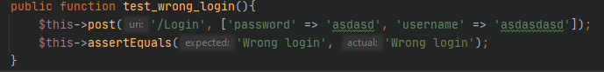



Logging out

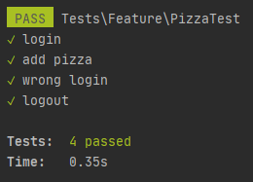

Adding pizza

Clearing order

Submitting order

**Unit Testing**

Adding pizza

Adding pizza with no price

Adding create your own with toppings

Adding create your own without toppings.

Adding pizza with no values

